Adapter
When you need to connect systems with incompatible interfaces, the Adapter Pattern works well. We need to connect an old SOAP-based payment system to a new e-commerce platform that uses a RESTful JSON API in this case.
Explanation:
The modern e-commerce platform can be considered the "Client" that wants to use the services of the legacy payment system, the "Service." The Client wants a RESTful JSON interface, but the Service only has a SOAP interface, so the two don't work together. We can fix this by adding an Adapter that works as a translator between the two systems.
The Adapter will get requests from the Client in the expected format (RESTful JSON), turn them into SOAP messages that the old payment system can understand, and send them to the Service. The Adapter takes the SOAP message from the Service and turns it back into a JSON response, which it then sends to the Client.
This way, the Client can interact with the Service without knowing its internal workings or interface details.

Python Code Example:
Consider the following simplified example, where LegacyPaymentSystem simulates a SOAP-based API and EcommercePlatform represents the modern e-commerce platform. We will create an Adapter class to bridge the two.
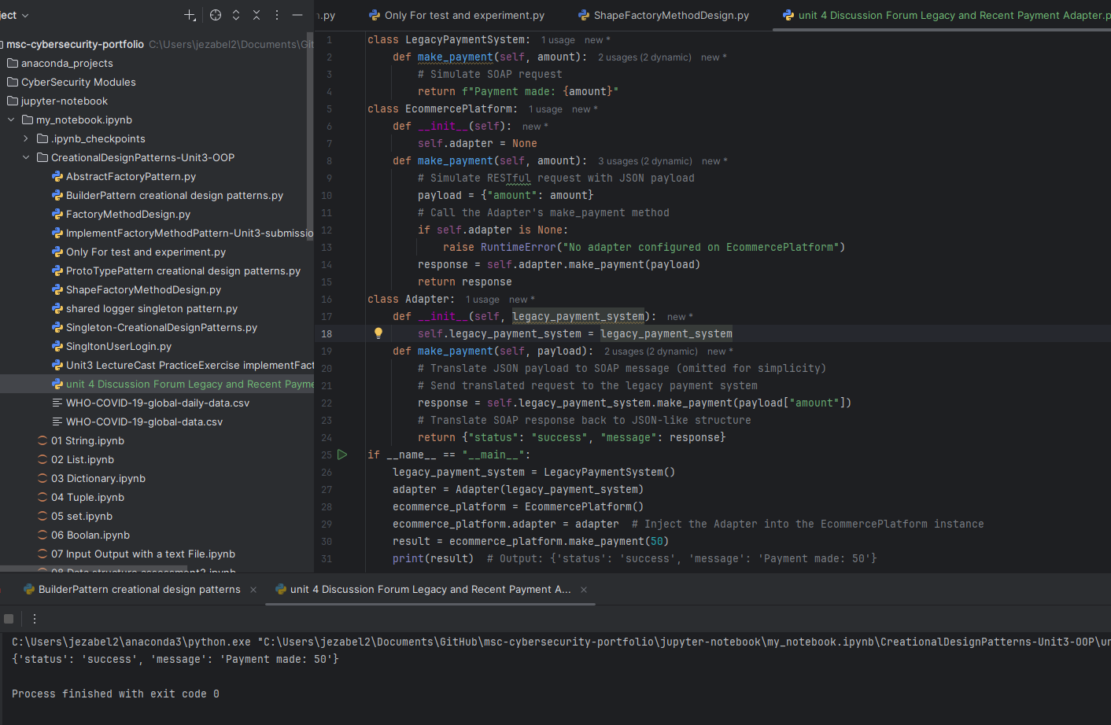

Bridge Pattern
When building systems that need to support multiple variations of functionality like different types of devices and their remote controls. The Bridge Pattern offers a clean and flexible solution. It’s especially useful when you want to avoid a combinatorial explosion of classes. Imagine having to create a separate class for every possible combination of device and remote control: BasicTVRemote, AdvancedTVRemote, BasicRadioRemote, and so on. That quickly becomes unmanageable.
The Bridge Pattern solves this by decoupling the abstraction from its implementation. In the provided Python code, Device is the implementation interface, with TV and Radio as concrete implementations. On the other side, RemoteControl is the abstraction, with BasicRemoteControl and AdvancedRemoteControl as its concrete classes.
Each remote control holds a reference to a Device, allowing it to operate on any device without knowing its internal workings. This means you can mix and match remotes and devices freely. For example, a basic remote can control a TV, and an advanced remote can control a radio without needing to rewrite or duplicate code.
This separation makes the system easier to extend and manage. For instance, if you want to add a new device like a projector. A sub class of Device (Projector(Device)) can be easily implemented without changing the RemoteControl classes . If the requirement requires only an extra remote control with voice recognition, so, a concrete subclass of RemoteControl (VoiceRemoteControl (RemoteControl))can be implemented without touching the device classes.
In short, the Bridge Pattern helps keep the code modular, scalable, and easier to maintain, especially when dealing with multiple dimensions of variation.

🧠 Understanding the Bridge Pattern Through Devices and Remotes
In software design, the Bridge Pattern is a powerful tool for separating concerns and promoting flexibility. It’s especially useful when you need to vary both the abstraction and its implementation independently. Let’s explore this through a relatable scenario: managing different types of devices and their remote controls.
🔹 The Problem Context
Imagine you're building a system to control electronic devices like TVs and Radios, each of which can be operated using different types of remote controls — say, a BasicRemoteControl and an AdvancedRemoteControl. At first glance, it might seem reasonable to create combinations like:
- BasicTVRemote
- AdvancedTVRemote
- BasicRadioRemote
- AdvancedRadioRemote
However, this approach quickly becomes unwieldy. As the number of devices and remote types grows, you face a class explosion — a proliferation of tightly coupled classes that are hard to maintain and extend. Each new combination requires a new class, and changes in one hierarchy ripple through the other.
🔹 The Bridge Pattern Solution
The Bridge Pattern addresses this by decoupling the abstraction from its implementation. In this case:
- The abstraction is the RemoteControl
- The implementation is the Device
Instead of embedding device-specific logic inside each remote, the pattern introduces a shared interface (Device) that all concrete devices (like TV and Radio) implement. The RemoteControl holds a reference to a Device and delegates control commands to it. This setup allows any remote to control any device, without knowing the details of how the device works.
🧩 Class Structure Overview
Here’s how the class hierarchy is organized:
- Device (interface)
- TV
- Radio
- RemoteControl (abstract class)
- BasicRemoteControl
- AdvancedRemoteControl
This structure forms a bridge between the abstraction and the implementation, allowing them to evolve independently.
🔍 How the Bridge Pattern Solves the Problem
- Decoupling: RemoteControl doesn’t need to know what kind of device it’s controlling. It simply calls turn_on() and turn_off() on the Device interface.
- Flexibility: You can introduce new remotes (e.g., VoiceRemoteControl) or new devices (e.g., SmartSpeaker) without modifying existing classes.
- Scalability: You avoid creating a new class for every remote-device combination. Instead, you compose them dynamically at runtime.

This pattern not only simplifies your architecture but also aligns with key object-oriented principles like composition over inheritance, interface segregation, and open/closed design. It’s a textbook example of how thoughtful abstraction can lead to elegant and maintainable code.
Would you like to extend this explanation with a diagram or annotated code snippet to reinforce the concept visually?

Python Code Demonstration and testing
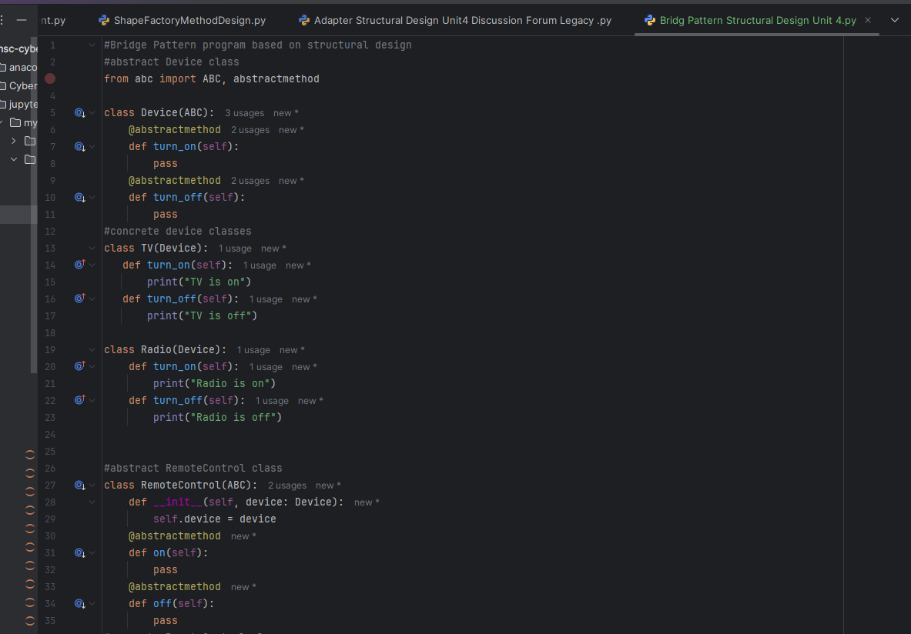
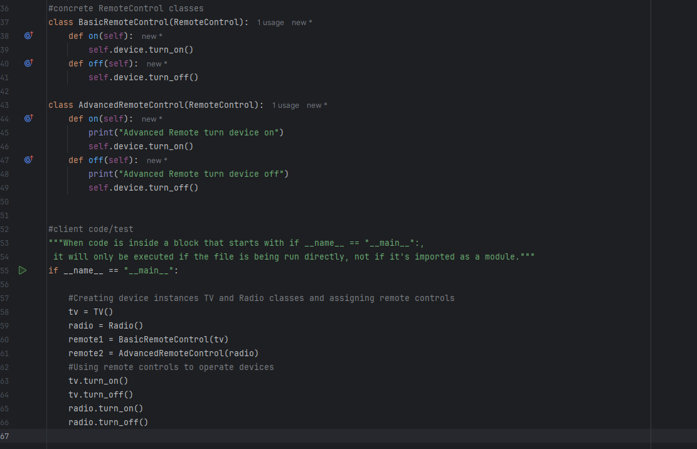
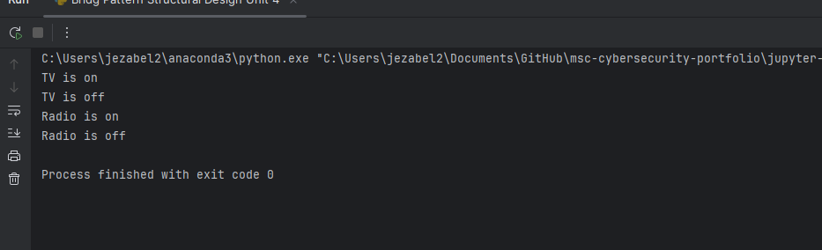

Composite pattern
When designing software that needs to handle complex hierarchies—like a file system—the Composite Pattern offers a clean and intuitive solution. It lets treating individual items and groups of items in the same way, which is especially useful when both files and folders share common attributes like names, sizes, and child counts, but behave differently under the hood.
In the Python example, we define a shared interface called FileSystemComponent, which both File and Folder classes implement. This means we can interact with either type without worrying about their internal differences. A File has a name and size, and no children. A Folder, on the other hand, can hold other files or folders, forming a tree-like structure.
The setup can handle operations like calculating total size. The Folder class uses recursion to sum the sizes of all its children, whether they’re files or nested folders. Therefore, when we call doc_folder.get_size(), it correctly returns the combined size of all instances within the folder (600) even if the contents are deeply nested.
This approach makes the system easier to scale and maintain. It is not necessary to separate logic for files and folders; the shared interface handles that. It’s a great example of how thoughtful design patterns can mirror real-world structures and simplify the way we build and reason about code.

Python code

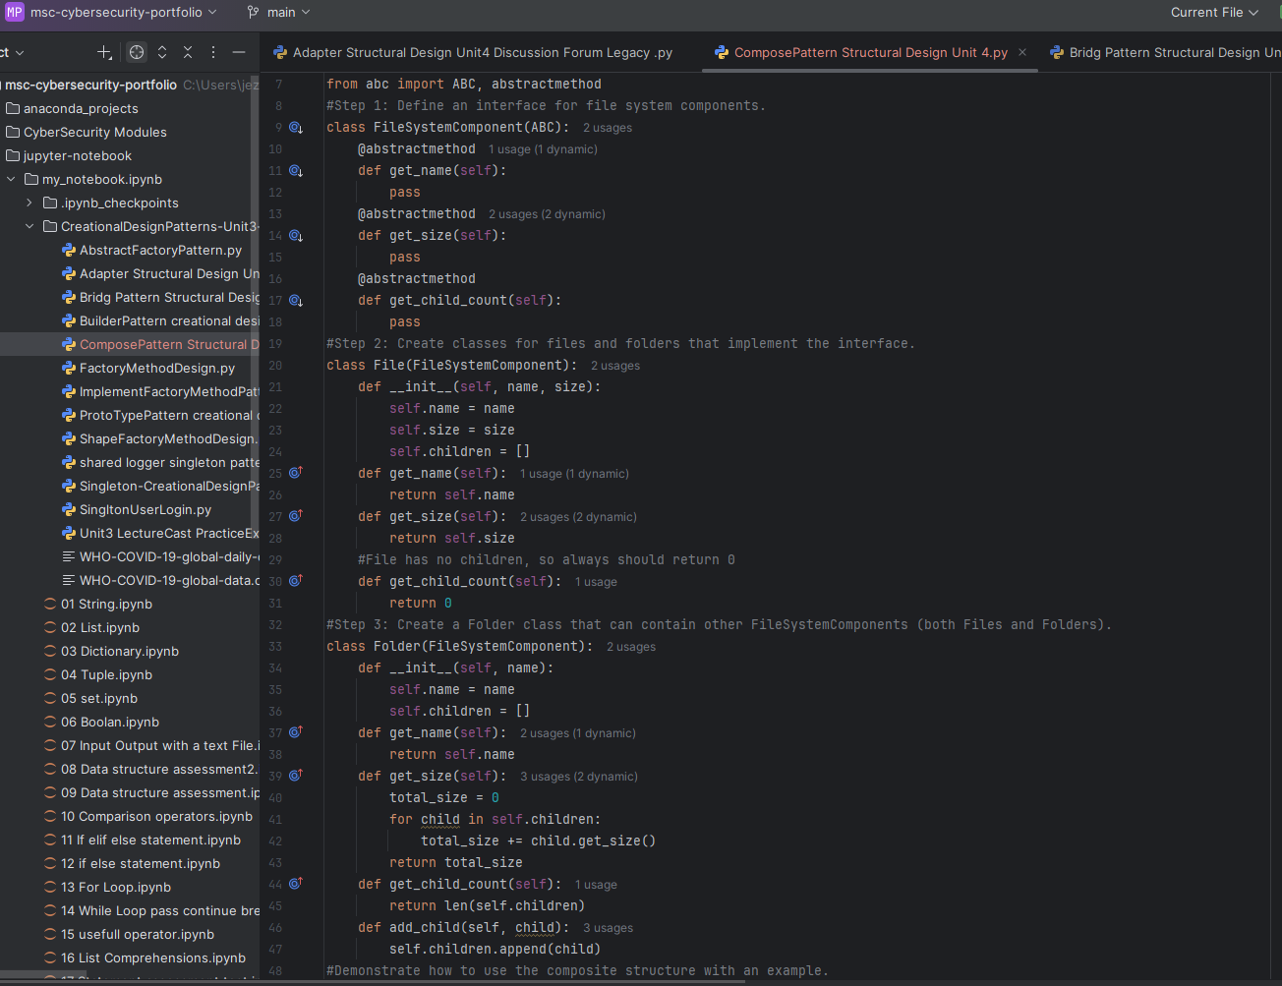
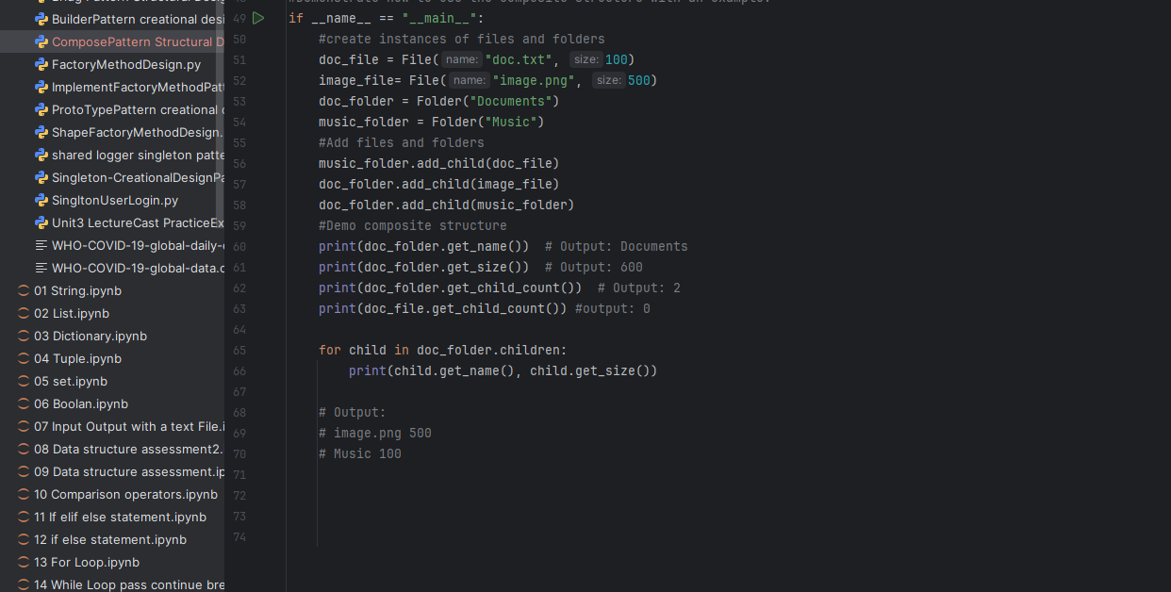
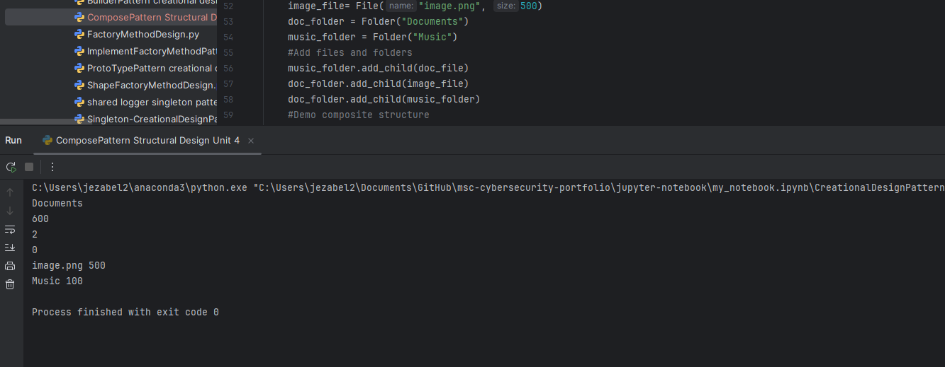

- Single Responsibility Principle (SRP): A class should have only one reason to change.
- Open/Closed Principle (OCP): Software entities should be open for extension but closed for modification.
- Liskov Substitution Principle (LSP): Subtypes must be substitutable for their base types.
- Interface Segregation Principle (ISP): Clients should not be forced to depend on interfaces they do not use.
- Dependency Inversion Principle (DIP): High-level modules should not depend on low-level modules; both should depend on abstractions.
- =======================
- Focus on Five Key Creational Design Patterns:
  - Singleton: Ensures a class has only one instance and provides a global point of access to it.
  - Factory Method: Defines an interface for creating objects but let's subclasses alter the type of objects created.
  - Builder: Separates the construction of a complex object from its representation.
  - Prototype: Allows cloning of objects without making the code dependent on their classes.
  - Abstract Factory: Provides an interface for creating families of related or dependent objects.

